***IS456:2000 WALL CODE PROVISIONS***

*GENERAL GRADE OF CONCRETE BUILDING M 20* ***[IS13920:2016 5.2]***

*Minimum thickness of special shear walls shall not be less than* ***[IS13920:2016 10.1.2]***

*150mm*

*300mm Coupled shear walls*

Minimum ratio length of wall to its thickness ***[IS13920:2016 10.1.3]***

***L/t >= 4***

Wall Classified as squat, intermediatre or slender ***[IS13920:2016 10.1.4]***

*hw/Lw < 1 squat wall*

*1 <= hw/Lw <=- 2 Intermediate wall*

*hw/Lw > 2 slender wall*

Flanged wall section, flanged shall be extends beyond the face of the web ***[IS13920:2016 10.1.4]***

Least of below

Actucal width

½ distance to the adjacent wall web

1/10 total wall height

Minimum Reinforcement in RC Shear Wall ***[IS13920:2016 10.1.6]***

Ph,min =0.0025

Pv,,min=0.0025+0.5($1-\frac{hw}{tw}$) * (ph – 0.0025)

Pv,,min=0.0025+0.5($1-\frac{hw}{tw}$) * (ph – 0.0025)

Pv,,provided=0.0025+0.5($1-\frac{hw}{tw}$) * (0.02-2.5*(pv,web))

Pv,provided < Ph,provided

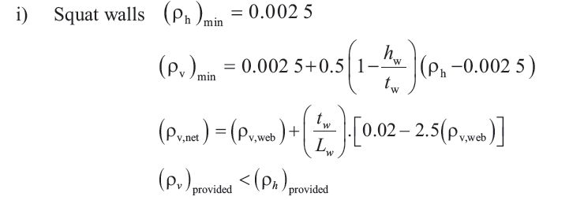

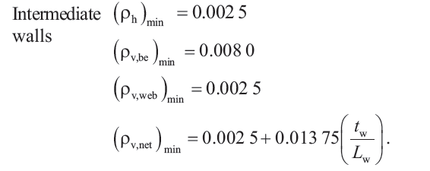

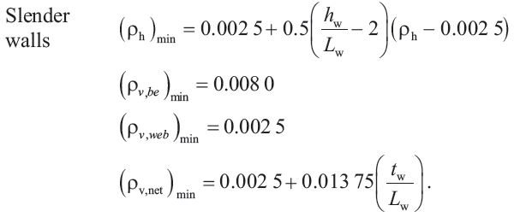

Reinforcement bars shallbe provided in two curtains within the cross section of the wall ***[IS13920:2016 10.1.7]***

If factored shear stress in wall exceeds 0.25 $\sqrt{fck}$ MPa

Wall thickness >=200 mm

Largest Diameter of Longitudinal steel bar <= 1/10 thickness of that part(wall?) ***[IS13920:2016 10.1.7]***

*Maximum Spacing of Vertical and Horizontal reinforcement shall not exceed smaller* ***[IS13920:2016 10.1.9]***

Least of below

*1/5 horizontal length Lw*

3 *x tw* Thickness of web of wall

450 mm

Nominal shear stress Tv ***[IS13920:2016 10.2.1]***

Tv = vu/twdw  dw can be taken as 0.8 Lw

Design Horizontal Shear Reinforcement Tv > Tc Ah = Vus /0.87fy(d/sv)= Vu - Tctwdw /0.87fy(d/sv**) [IS13920:2016 *10.2.3]***

Minimum area of horizontal steel >= VH (TABLE1)

Annex A applicable for slender rectangular structural wall but not applicable for boundary elements. **) [IS13920:2016 *10..3.1]***

Cracked flexural strength > Uncracked flexural strength **[IS13920:2016 *10..3.2]***

If structural wall no boundary elements then Min 4 bars of 12 mm diameter **[IS13920:2016 *10..3.3 ]***

in 2 layers as Vertical reinforcement at end of wall length

not exceeding twice the thickness of RC wall

Boundary Element are portions along the wall edge, thickness equal to web or greater than web **[IS13920:2016 *10.4 ]***

*Boundary elements if etreme fibre compressive stress exceeds 0.2fck* **[IS13920:2016 *10.4.1]***

Boundary elements may be discontinued at extreme fibre stress <0.15fck

Loadfator for gravity load shall be taken as 0.8 **[IS13920:2016 *10.4.3]***

*Boundary elements, special confining reinforcement*

*Ash = 0.05 s*v *h fck/fy*

Spacing Not more than below

1/3 minimum dimension of boundary element

6 x dia small longitudinal reinforcement bar

100 mm

Moment of resistance of rectangular shear wall section **[IS13920:2016 Annex A]**

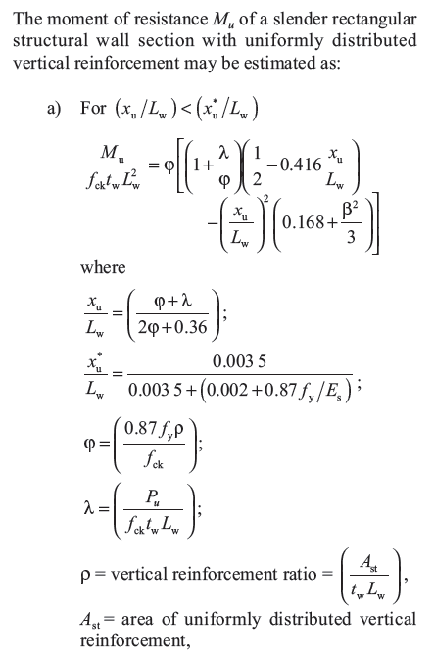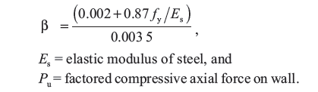

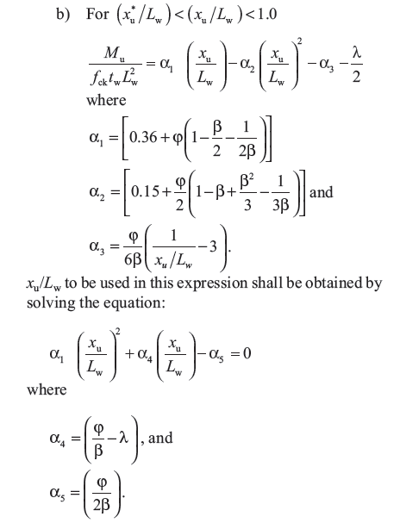

= 0.063

COLUMN SPECIFICATIONS

Column definition Column Effective Length > 3 x Minmum(b,d) **[IS456:2000 25.1.1]**

Short Column EffectiveLength(lx)/D < 12 and ly/b < 12 **[IS456:2000 25.1.2]**

Long Column EffectiveLength /D >= 12 or y/b >= 12  **[IS456:2000 25.1.2]**

Slenderness Limit

End Restrained: UnsupportedLength <= 60 x Minimum(b,d) **[IS456:2000 25.3.1]**

One end Unrestrained(cantilever): UnsupportedLength <= 100 b2 /D **[IS456:2000 25.3.2]**

Minimum Eccentricity **[IS456:2000 24.4]**

Min of below

UnsupportedLength(l)/500 + RespectiveLateralDimension(b,d)/30

20 mm

Cover Minimum Cover >= 40 **[IS456:2000 26.4.2.1]**

**[IS456:2000 26.4.2.1]**

Min Reinforcement **0.008 b d** (gross cross section) **[IS456:2000 26.5.3.1]**

Max Reinforcement **0.06 b d** (gross cross section) **[IS456:2000 26.5.3.1]**

Min Bar diameter **dia >=12 mm [IS456:2000 26.5.3.1_d]**

Max spacing of main bar along Peiphery outer edge **spacing <= 300 [IS456:2000 26.5.3.1_h]**

**Lateral ties min spacing**  **[IS456:2000 26.5.3.2_c]**

Min of below 3

Min (b,d)

16 Dia(longitutional)

300

**Dia of tie/Helical [IS456:2000 26.5.3.2_d]**

Max of below :

¼ dia of large longitudinal bar

16

* Max Compressive Strain in concrete ‘Concrete in Compressive only’

**0.002 [IS456:2000 39.1]**

* Max Compressive Strain in concrete concrete ‘Concrete in Compressive and bending’ when there is no tension in the section

**0.0035 – 0.75 x strain in least compressive fibre [IS456:2000 39.1]**

**Short Axially Loaded Column**   **[IS456:2000 39.3]**

Le/b < 12 short column

UnsupportedLength(l)/500 + RespectiveLateralDimension(b,d)/30 <= 0.05 x Lateral Dimension <= 20

Pu = 0.4 fck Ac + 0.67 fy Asc

**Members Subjected to Combined Axial Load and Biaxial Bending [IS456:2000 39.6]**

${\left[\frac{Mux}{Mux1}\right]}^{∝n}+ {\left[\frac{Muy}{Muy1}\right]}^{∝n}≤ 1.0$ This ensure that this that member is with in the Circle or curve dose not fail

$∝n$***= Pu/ Puz***

***Puz =*** 0.45fck Ac + 0.75 fy Asc  

**Slender compression members [IS456:2000 39.7]**

Additional Moment

Reduction Factor **[IS456:2000 39.7.1.1]**

**

Concrete Shear Capacity  **[IS456:2000 40.4 c] [T table 19]**

***Shear Strength of Members Under axial [*IS456:2000  *40.2.2]***

*Design shear strength of table119 must multiply with factor*

*Detla = 1 + 3 Pu / Ag fck*

***Tc*** *x Delta*

* + - * + Design Shear Strength of Concrete ***Tc [*IS456:2000 *Table 19]***

*Shear Strength of Concrete* ***Tc*** ***[SP 24 39.2.1]***



*Shear Strength of Concrete Tcmax*  ***[Table 20 , SP 16 pno124]***

Reinforce Shear Capacity   **[IS456:2000 40.4 c]**

* + - * + Minimum shear reinforcement **[IS456:2000 26.5.1.6]**

**Effective Length [IS456:2000 Annex E ]**

As PER Table 28 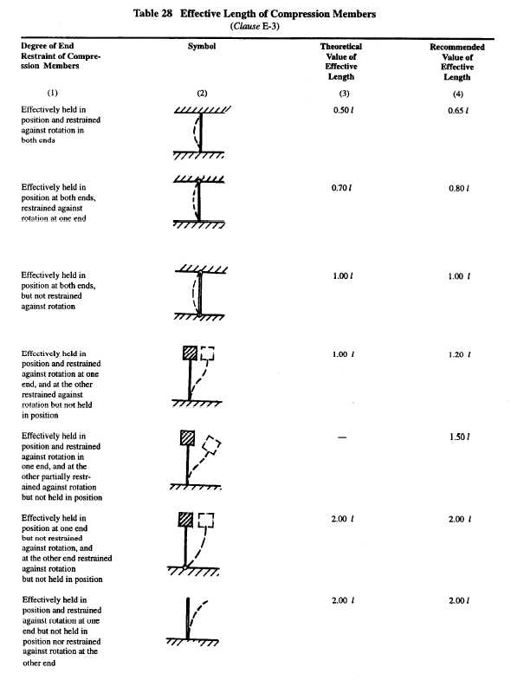

**Serviceability for Compression Member [IS456:2000 43.2]**

To considered flexural member for purpose of crack control

Axial load **<=** 0.2 fck Ac

**Design surface Crack Width**  **[IS456:2000 Annex F]**

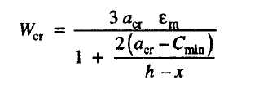

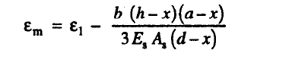

**Cracking Limits** **[IS456:2000 35.3.2]**

For Appearance Condition Crack Width Not Exceed 0.3 mm

For Moderate Exposer Condition Crack Width Not Exceed 0.2 mm

For Severe Exposer Condition Crack Width Not Exceed 0.1 mm

For Aggressive Condition Crack width not Exceed 0.004 mm

**Splicing**  **[IS456:2000 26.5.5.1]**

Lap splices

Ø ≤ 36 mm

If ø ≥ 36 mm provide spirals around lapped bar

++

**Maximum Allowable Spacing of shear steel [IS456:2000 26.5.1.5]**

Min of below

0.75 d

300

**Minimum****Distance between Individual Bars *[*IS456:2000 26.3.2]**

Not greater than this :

Dia of Large Bar

5mm + 20aggregate size

Check ratio of tensile reinforcement

Calculate Neutral axis  **[IS456:2000 ANNEX G]**

Calculate Moment Capacity  **[IS456:2000 ANNEX G]**

Calculate Moment Capacity compression steel  **[IS456:2000 ANNEX G 1-2]**

xu.max the limiting value of xU **xu.max** **[IS456:2000 38.1]**

* + - * + ***Stress in Compression Steel fsc*  [IS456:2000 Annex G 1.2]**

***Xu / d Limit [*IS456:2000 *Table 20 , SP 16 pno124]***

**IS 13920 DUCTAIL DETAILING [IS13920:2016]**

**If Splicing [IS13920:2016 7.3.2.1]**

Link spacing <= 100 mm spacing

mainBar Dia <= 32 mm

Hook **135** degree and must extend 6 times its diameter and >=65 mm **[IS13920:2016 7.4.1]**

Show in Drawings

**Links spacing [IS13920:2016 7.4.2]**

Minimum bar Dia >= 8mm

Maximum bar Dia <= 32mm

If Dia of long bar is 32 mm then minimum bar dia <= 10

Max spacing links(TieBar) <= 300

Spacing<= ½ min(b,d)

If length of link is >= 300 provide cross link

**Shear Force in Columns** sagging-hogging **[IS13920:2016 7.5]**

For Sway to Right Vu = 1.4 (MuAs  + MuBh )/hst

For Sway to Left Vu = 1.4 (MuAh  + MuBs )/hst

**SPECIAL CONFINING REINFORCEMENT**

Cross section area of bar **Link or spiral** Over length lo  **[IS13920:2016 8.1.3]**

**Ash** Max of below

0.09 Sv Dk  fck/fy (Ag/Ak – 1 )

0.24 sv Dk fck / fy

Cross section area of bar **Link or Rectangle** Over length lo **[IS13920:2016 8.1.3]**

**Ash** Max of below

0.18 Sv sh h fck/fy (Ag/Ak – 1 )

0.05 sv h fck / fy